**A survey about the factors affect students' Mathematical Analysis grade/ 一份关于影响学生数学分析成绩的调查问卷**

第1题 Which time slot is your current class?/ 您当前的数学分析课程的上课时间？ [单选题]

|  |  |  |
| --- | --- | --- |
| 选项 | 小计 | 比例 |
| Period 1-2/ 1-2节 | 31 | 50% |
| Period 3-4/ 3-4节 | 31 | 50% |
| 本题有效填写人次 | 62 |  |

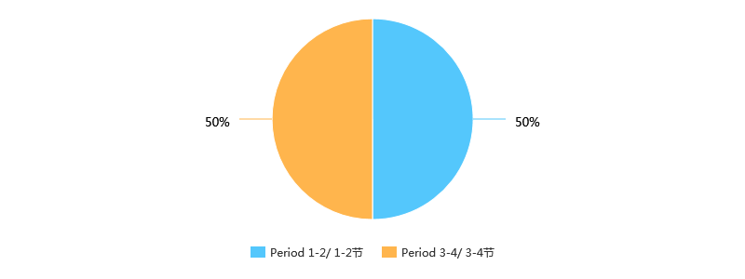

第2题 How is your attendance this semester?/ 您这学期的出勤情况？ [单选题]

|  |  |  |
| --- | --- | --- |
| 选项 | 小计 | 比例 |
| Never missed a class/ 从不缺勤 | 49 | 79.03% |
| Have missed class(es), but missed no more than 2 class/ 缺勤1-2次 | 9 | 14.52% |
| Have missed more than 2 but no more than 5 classes/ 缺勤3-5次 | 2 | 3.23% |
| Have missed more than 5 but no more than 10 class/ 缺勤5-10次 | 1 | 1.61% |
| Have attended class, but missed more than 10 classes/ 有出勤，但缺勤多于10次 | 0 | 0% |
| Never attend class/ 从不出勤 | 1 | 1.61% |
| 本题有效填写人次 | 62 |  |

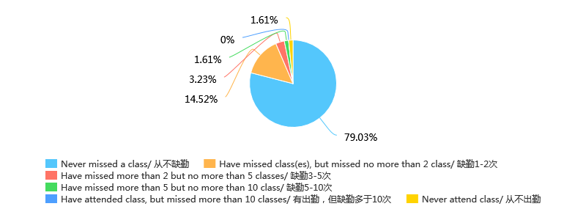

第3题 How often are you late for class this semester?/ 您这学期的迟到情况？ [单选题]

|  |  |  |
| --- | --- | --- |
| 选项 | 小计 | 比例 |
| Never be late/ 从不迟到 | 36 | 58.06% |
| Have been late but no more than 2 times/ 迟到过1-2次 | 18 | 29.03% |
| Have been late more than 3 times but no more than 5 times/ 迟到过3-5次 | 7 | 11.29% |
| Have been late more than 5 times but no more than 10 times/ 迟到过5-10次 | 1 | 1.61% |
| Have been late more than 10 times/ 迟到超过10次 | 0 | 0% |
| Be late for every class/ 每节课都迟到 | 0 | 0% |
| 本题有效填写人次 | 62 |  |

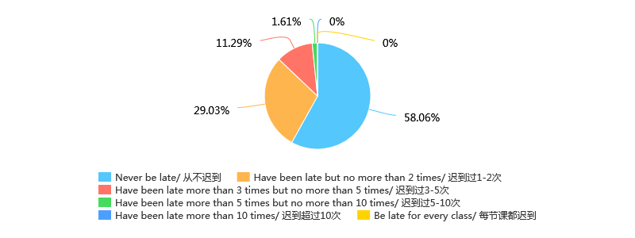

第4题 How is your mental state in class？/ 您上课时的精神状态？ [单选题]

|  |  |  |
| --- | --- | --- |
| 选项 | 小计 | 比例 |
| Extremely concentrated/ 极其专注 | 3 | 4.84% |
| Attentive/ 认真 | 18 | 29.03% |
| OK/ 还行 | 23 | 37.1% |
| Distracted/ 分心，做其他事情 | 13 | 20.97% |
| Sleepy/ 困倦，昏昏欲睡 | 4 | 6.45% |
| Asleep/ 睡眠模式已开启 | 1 | 1.61% |
| 本题有效填写人次 | 62 |  |

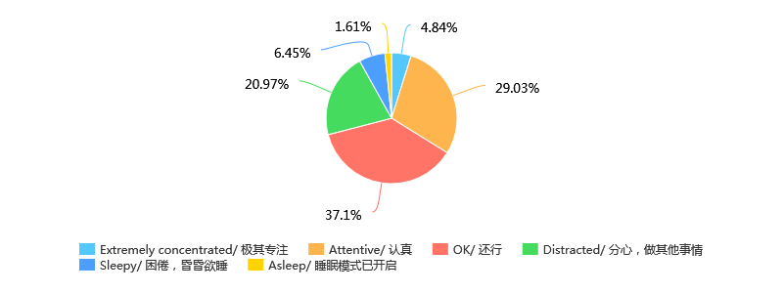

第5题 Can you follow teacher's thinking?/ 您是否能够跟上老师的思路？ [单选题]

|  |  |  |
| --- | --- | --- |
| 选项 | 小计 | 比例 |
| Absolutely/ 完全可以 | 5 | 8.06% |
| Mostly/ 通常可以 | 33 | 53.23% |
| Basically/ 基本可以 | 10 | 16.13% |
| Sometimes/ 偶尔可以 | 11 | 17.74% |
| Never/ 这**都在讲什么呀 | 3 | 4.84% |
| 本题有效填写人次 | 62 |  |

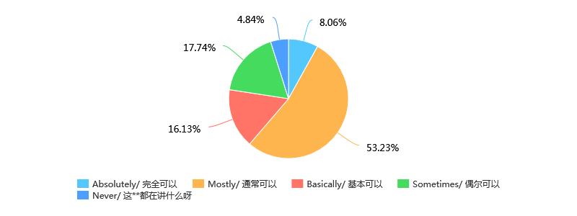

第6题 How often do you finish your homework this semester?/ 您本学期的作业完成情况？ [单选题]

|  |  |  |
| --- | --- | --- |
| 选项 | 小计 | 比例 |
| Always finish/ 每次都完成 | 58 | 93.55% |
| Have missed but no more than 2 times/ 有1-2次未完成 | 2 | 3.23% |
| Missed more than 2 but no more than 5 times/ 有3-5次未完成 | 1 | 1.61% |
| Missed more than 5 but no more than 10 times/ 有5-10次未完成 | 0 | 0% |
| Missed more than 10 times/ 超过10未完成 | 1 | 1.61% |
| Never finish/ 从不完成 | 0 | 0% |
| 本题有效填写人次 | 62 |  |

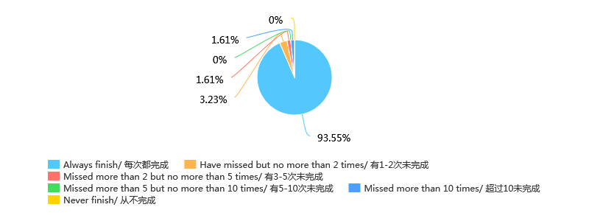

第7题 How difficult is the homework for you?/ 您觉得作业的难度？ [单选题]

|  |  |  |
| --- | --- | --- |
| 选项 | 小计 | 比例 |
| Too simple/ 过于简单 | 0 | 0% |
| Simple/ 偏简单 | 1 | 1.61% |
| Normal/ 难度适中 | 32 | 51.61% |
| Difficult/ 偏困难 | 27 | 43.55% |
| Too difficult/ 过于困难 | 2 | 3.23% |
| 本题有效填写人次 | 62 |  |

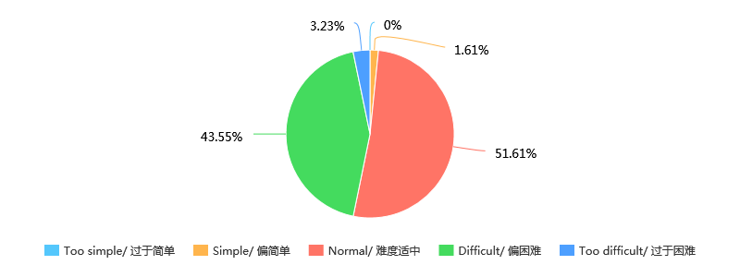

第8题 Which time slot is your class last semester?/ 您上学期的数学分析课程的上课时间？ [单选题]

|  |  |  |
| --- | --- | --- |
| 选项 | 小计 | 比例 |
| Period 1-2/ 1-2节 | 34 | 54.84% |
| Period 3-4/ 3-4节 | 28 | 45.16% |
| 本题有效填写人次 | 62 |  |

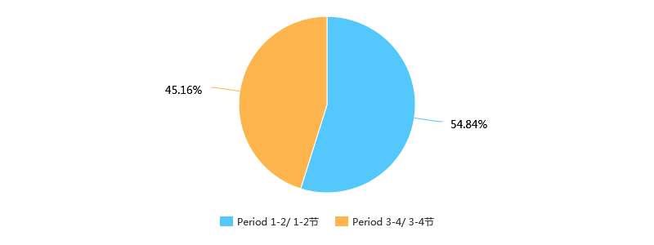

第9题 What range is of your grade of the first examination this semester at?[avg——average grade]/ 您这学期第一次数学分析考试的成绩区间？[avg——平均成绩] [单选题]

|  |  |  |
| --- | --- | --- |
| 选项 | 小计 | 比例 |
| [0, avg - 20) | 5 | 8.06% |
| [avg - 20, avg - 10) | 2 | 3.23% |
| [avg - 10, avg) | 16 | 25.81% |
| [avg, avg + 10) | 14 | 22.58% |
| [avg + 10, avg + 20) | 15 | 24.19% |
| [avg + 20, 100] | 10 | 16.13% |
| 本题有效填写人次 | 62 |  |

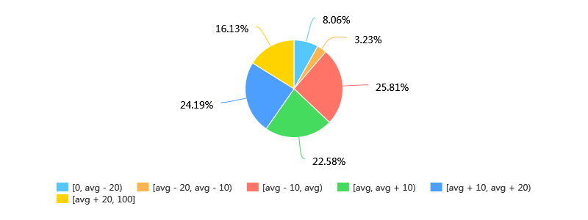

第10题 What range is your grade of the mid-term examination last semester at?/ 您上学期期中考试(第二次考试)的成绩区间？[avg——平均成绩] [单选题]

|  |  |  |
| --- | --- | --- |
| 选项 | 小计 | 比例 |
| [0, avg - 20) | 3 | 4.84% |
| [avg - 20, avg - 10) | 4 | 6.45% |
| [avg - 10, avg) | 15 | 24.19% |
| [avg, avg + 10) | 21 | 33.87% |
| [avg + 10, avg + 20) | 13 | 20.97% |
| [avg + 20, 100] | 6 | 9.68% |
| 本题有效填写人次 | 62 |  |

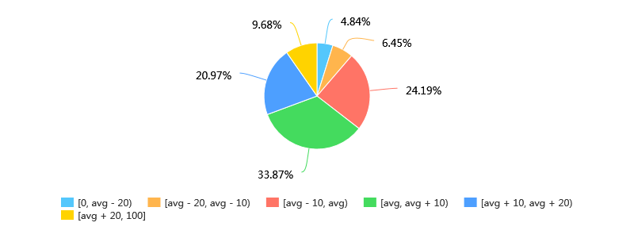

第11题 Do you think that there is any difference of learning effect between the students taking Period 1-2 and 3-4 class?(Glad if you can offer your reason.)/ 您认为上第1-2节课和第3-4节课的同学的学习效果有什么差异吗？(如果能填上您认为的原因，感激不尽) [单选题]

|  |  |  |
| --- | --- | --- |
| 选项 | 小计 | 比例 |
| Students taking Period 1-2 class learn better/ 上第1-2节课的同学学习效果更好 | 7 | 11.29% |
| Students taking Period 3-4 class learn better/ 上第3-4节课的同学学习效果更好 | 33 | 53.23% |
| No difference/ 没有差异 | 9 | 14.52% |
| I do not Know/ 不知道 | 13 | 20.97% |
| 本题有效填写人次 | 62 |  |

